CS 255 System Design Document Template

This template lays out all the different sections that you need to complete for Project Two. Each section has guidance to prompt your thinking. You will need to continually reference the interview transcript as you work to make sure that you are addressing your client’s needs. There is no required length for the final document. Instead the goal is to complete each section based on what your client’s needs are. Remove this note when you are finished, and replace all bracketed text with the relevant information.

UML Diagrams

UML Use Case Diagram
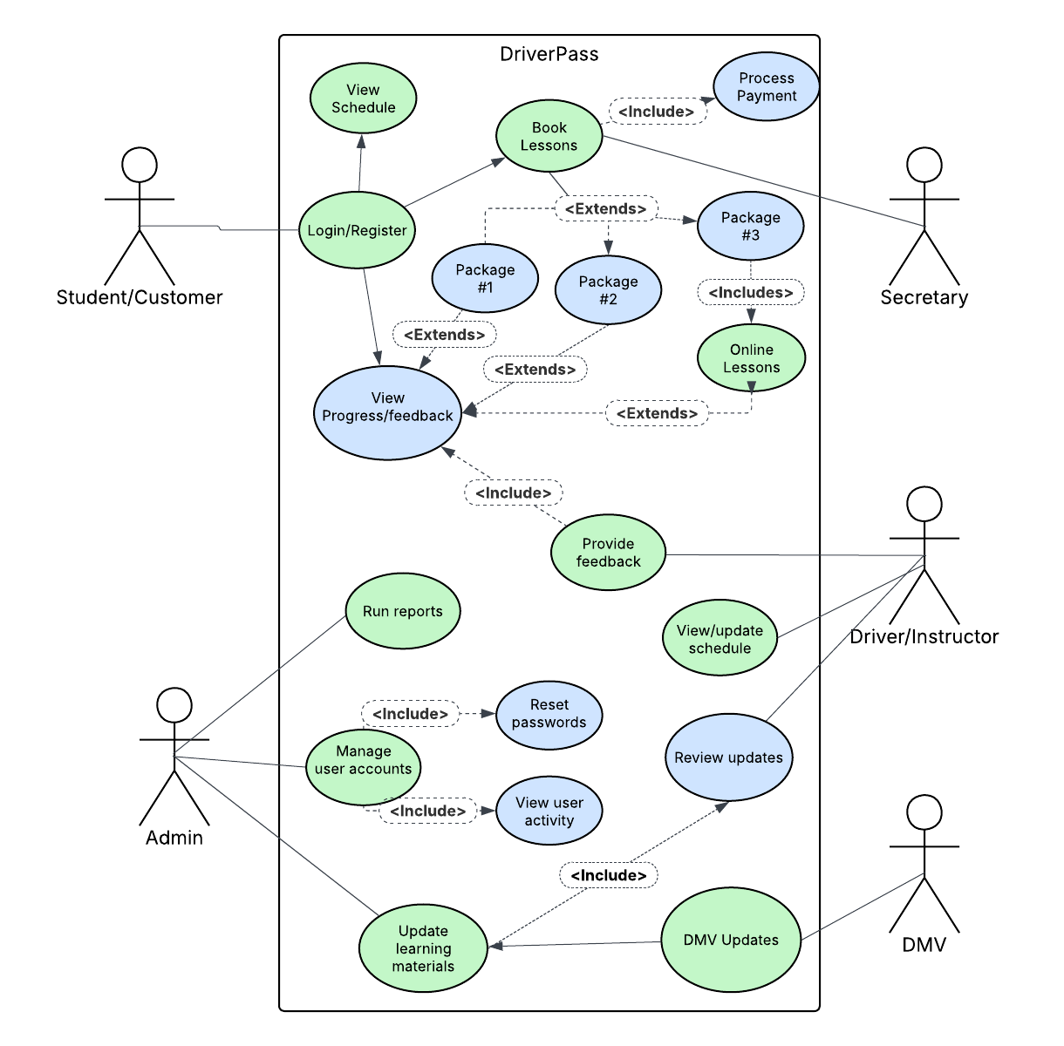

UML Activity Diagrams
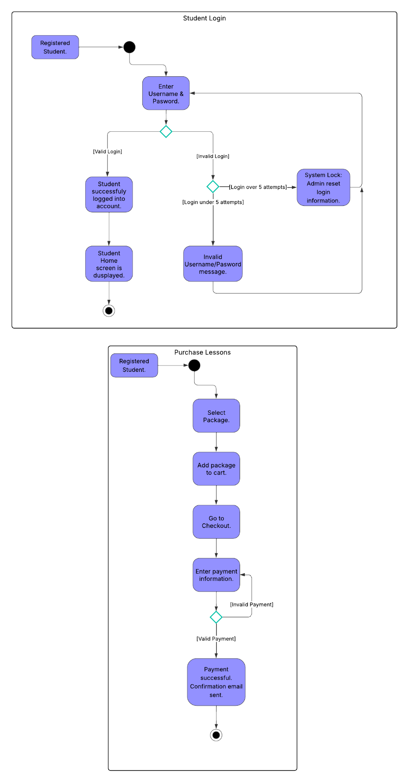

UML Sequence Diagram
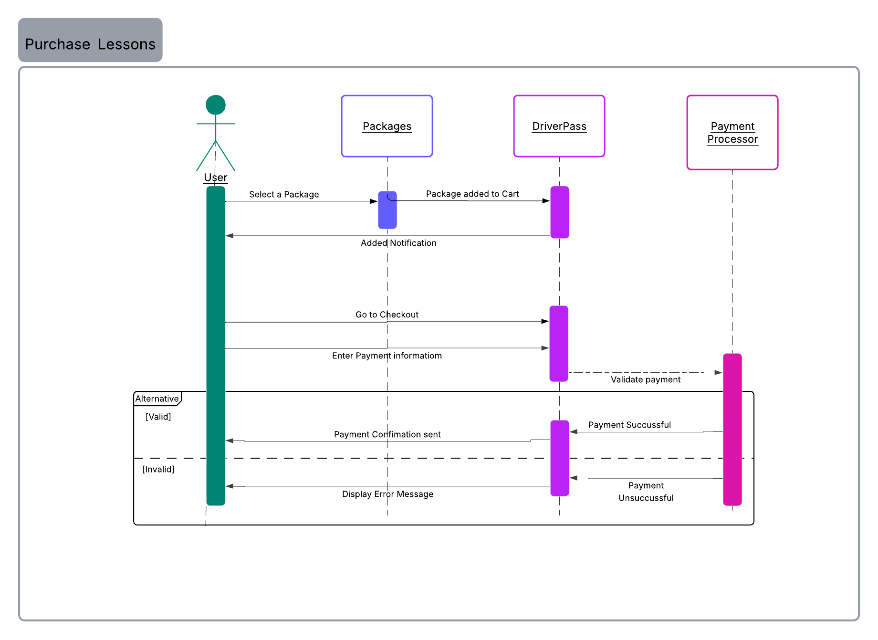

UML Class Diagram
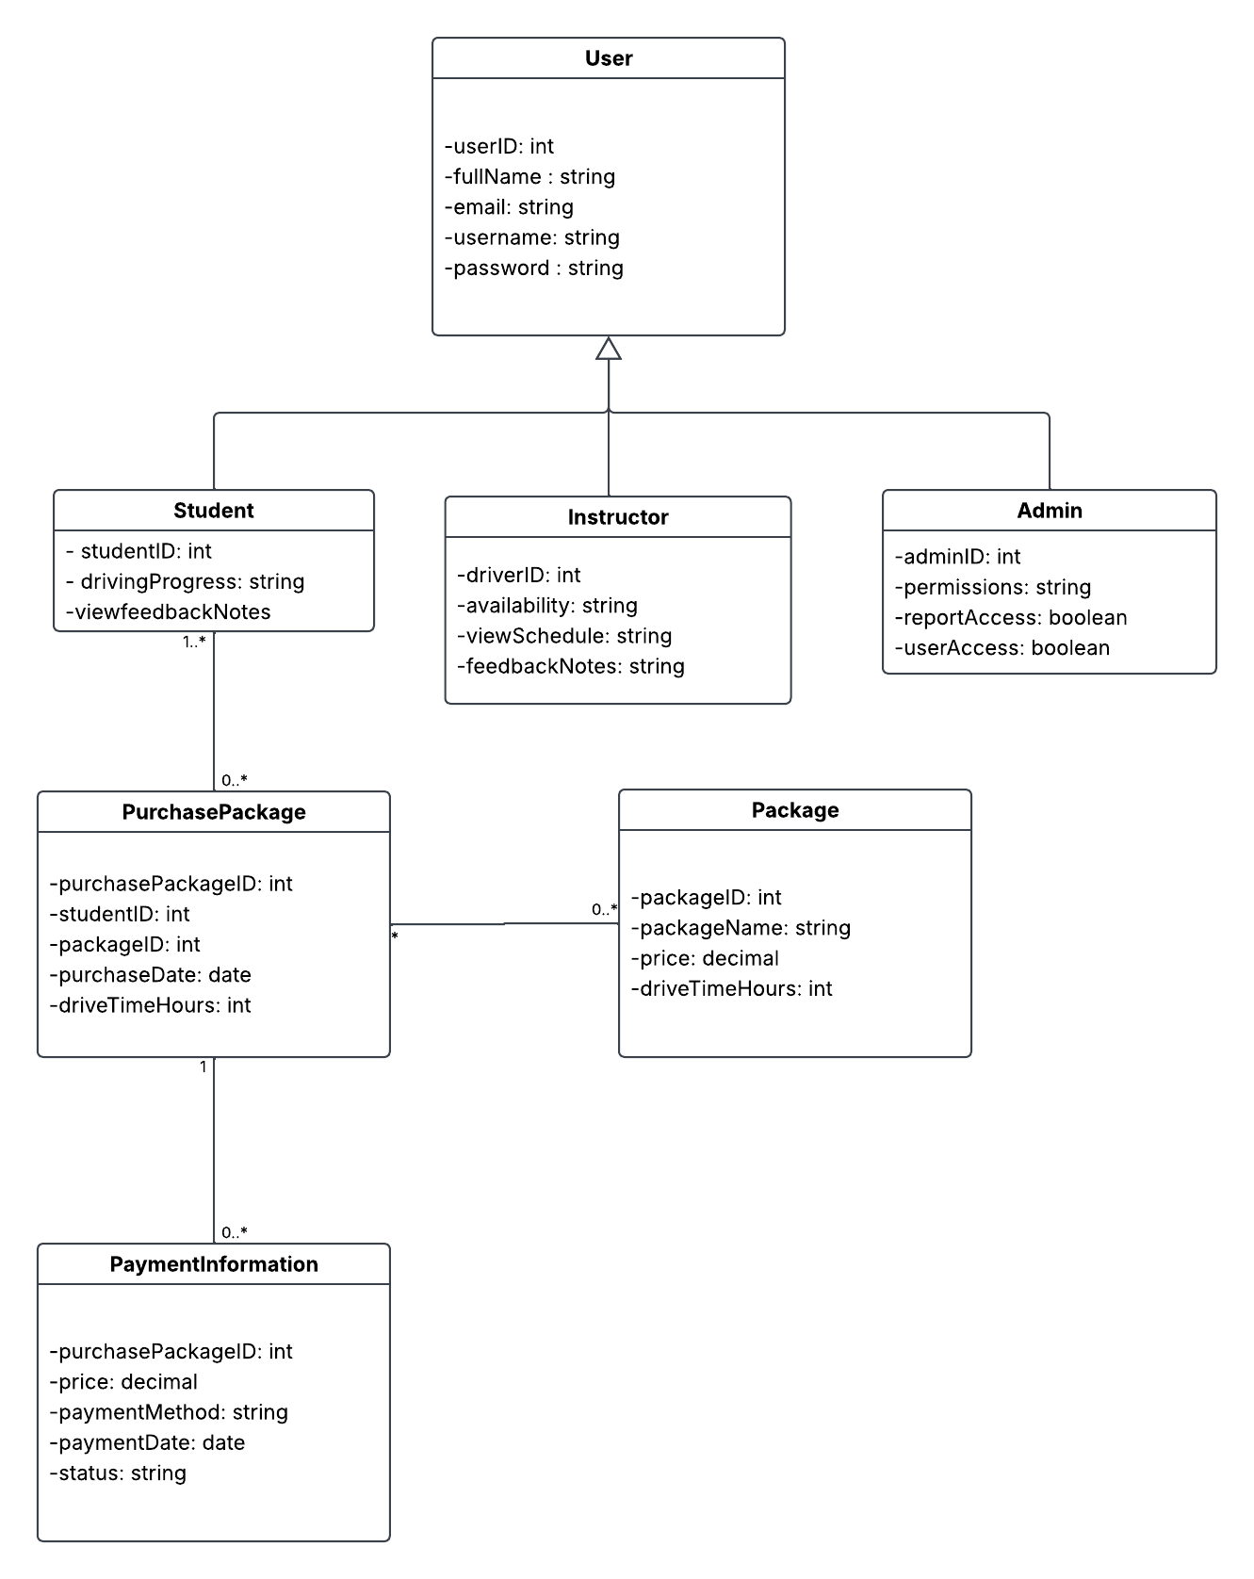

Technical Requirements
DriverPass would be a cloud-based web system so students, instructors and admins can access it from anywhere without needing any local setup. Since it handles things like scheduling and payments, it would need scalable cloud servers to handle higher traffic when needed. A MySQL database would work well because everything in the system is connected, like users, lessons, packages, feedback and payments, so it helps keep the data organized and consistent. The system would run as a web app with a front end for user interaction and a back end for handling logic and database communication. It needs to rely on cloud infrastructure with backups to keep everything running smoothly and protect the data.

